Description on how to download Historical Daily and Last-trade Cryptocurrency Data from Coinmarketcap:

More than one thousand crypto currencies are being traded nowadays. The coinmarketcap.com provides free historical daily data and market capitalization data.

https://coinmarketcap.com/all/views/all/

Individual cryptocurrency data may be fetched from, for example, Bitcoin:

https://coinmarketcap.com/currencies/bitcoin/historical-data/?start=20161206&end=20171206

Symbols to Use:

As the above URL contains the Name (or derivative from the Name) instead of the Symbol used on the coinmarketcap.com site, for the ease of processing and recognizing the individual cryptocurrencies, the Names will be used in the ticker list.

A sample ticker list, valid as of 7 Dec 2017, is “Coinmarketcap_D.tic”.

Set-up for Historical EOD Data:

- Copy the following line and append to your existing “mywebserver.txt” in the program installation folder, or simply substitute it with the “mywebserver.txt” file provided.

Coinmarketcap_D,https://coinmarketcap.com/currencies/SSSS/historical-data/?start=yy4ymm1mdddd&end=YY4YMM1MDDDD,D2,Coinmarketcap_D2.fmt

- Copy the “Coinmarketcap_D2.fmt” file to the “fmt” subfolder in the data file location.

- Run HSQuote Plus and set up “Coinmarketcap_D.tic” as shown below, or place the given “Coinmarketcap_D.tic” in the data file location subfolder.

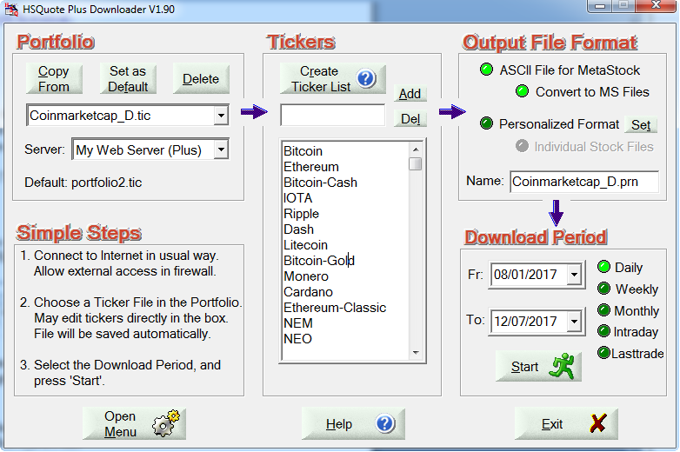

Last-trade Data:

As cryptocurrencies fluctuate a lot from minute to minute, some users may want to fetch the last-trade data before end of the day. They can store the last-trade data together with the EOD data in the MetaStock data files for chart viewing. The last-trade data will be applied to High, Low, Open and Close values, and Volume will be zero, and stored on the current date.

We will use the same ticker list.

Set-up for Additional Last-trade Data:

- Copy the following line and append to your existing “mywebserver.txt” in the program installation folder, or simply substitute it with the “mywebserver.txt” file provided.

Coinmarketcap_D,https://coinmarketcap.com/currencies/SSSS/historical-data/,L1,Coinmarketcap_L1.fmt

- Copy the “Coinmarketcap_L1.fmt” file to the “fmt” subfolder in the data file location.

- Run HSQuote Plus and use the same “Coinmarketcap_D.tic” as shown below, but use the ‘Lasttrade’ to download.

